Toss the Beans

5 bean bags per team member

PLEASE RETURN BEAN BAGS TO START LINE

Ring the Pumpkins

5 rings per team member

PLEASE RETURN RINGS TO START LINE

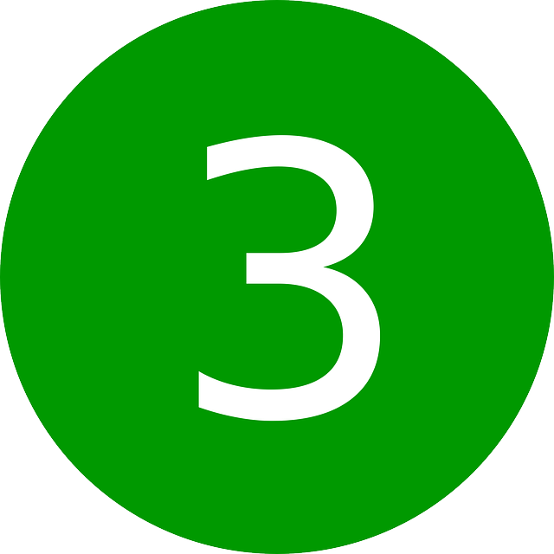
Pass the Ball

1 hit per hoop
Use the ball placed at each hoop start line

PLEASE RETURN EACH BALL TO START LINE

Bowl ‘Em Over

2 attempts per team member
to knock down all 10 pins

PLEASE RETURN BALLS TO START LINE
AND SET UP PINS

Cob Toss

1 corn cob per bucket
5 corn cobs per team member

PLEASE RETURN CORN COBS TO START LINE

Pin the Schnoz

1 attempt per team member
1 hand behind back and blindfolded

PLEASE RETURN NOSE PIECES TO START LINE

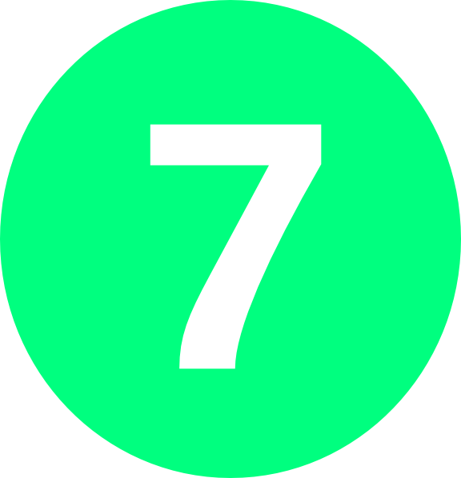

Spin & Play

1 spin per team member
Earn points by completing the task

Pick-a-Pumpkin

2 picks per team member

PLEASE RETURN PUMPKINS INTO BOWL

