FIND THIS IN THE BIBLE  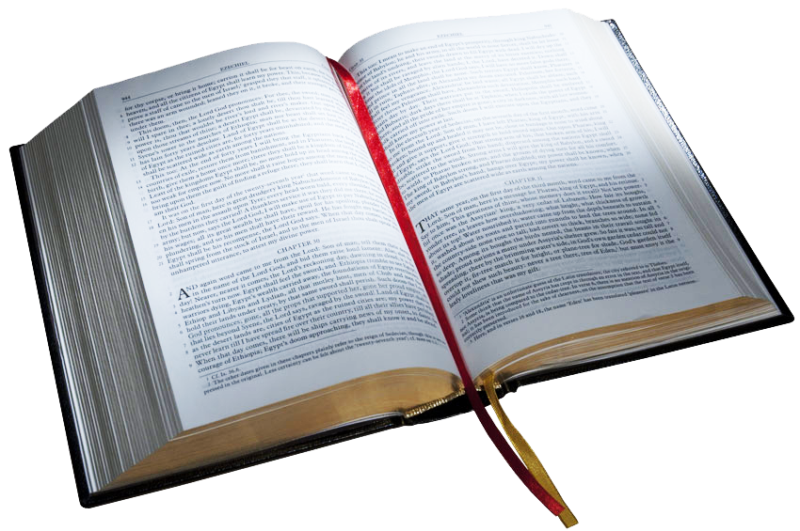  Discipline | FIND THIS IN THE BIBLE  Race
FIND THIS IN THE BIBLE  Persevere | FIND THIS IN THE BIBLE  Faith
FIND THIS IN THE BIBLE  Patience | FIND THIS IN THE BIBLE  Forgive
FIND THIS IN THE BIBLE  Obey | FIND THIS IN THE BIBLE  Healing
FIND THIS IN THE BIBLE  Father | FIND THIS IN THE BIBLE  Children

